Fell Deeds and Paints

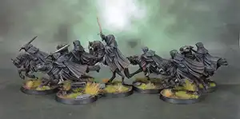

Who We Are
Fell Deeds and Paints is meant to act as a place where tabletop gamers can converge and interact as a community. It also serves as a marketplace for commission painters. We offer high-quality miniature painting services with competitive prices that allow us to improve anyone’s tabletop experience.

Price List
